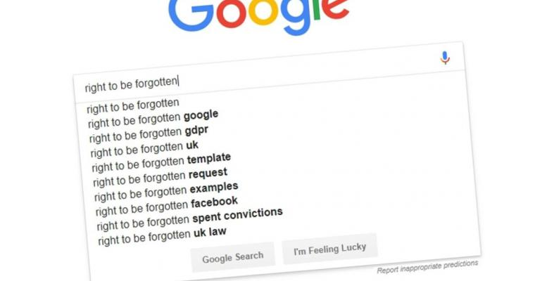

Google screenshot Source: Goolge/Bloomberg

[**SECURITY**](https://www.itprotoday.com/security)**>**[**COMPLIANCE**](https://www.itprotoday.com/security/compliance)

**Google Wins Round in Fight Against Global Right to Be Forgotten**

Google shouldn’t have to apply the so-called right to be forgotten globally, an adviser to the EU’s top court said in a boost for the U.S. giant’s fight with a French privacy regulator over where to draw the line between privacy and freedom of speech.

[Bloomberg](https://www.itprotoday.com/author/null-Bloomberg) | Jan 10, 2019

(Bloomberg) -- Google shouldn’t have to apply the so-called right to be forgotten globally, an adviser to the EU’s top court said in a boost for the U.S. giant’s fight with a French privacy regulator over where to draw the line between privacy and freedom of speech.

While backing Google’s stance, Advocate General Maciej Szpunar of the EU Court of Justice said that search engine operators must take every measure available to remove access to links to outdated or irrelevant information about a person on request. The Luxembourg-based court follows such advice in a majority of its final rulings, which normally come a few months after the opinions.

Google has been fighting efforts led by France’s privacy watchdog to globalize the right to be forgotten, which was created by the EU court in a landmark ruling in 2014, without defining how, when and where search engine operators should remove links. This has triggered a wave of legal challenges.

The Alphabet Inc. unit currently removes such links EU-wide and since 2016 it also restricts access to such information on non-EU Google sites when accessed from the EU country where the person concerned by the information is located -- referred to as geo-blocking. This approach was backed by Szpunar.

**‘Global Human Rights’**

“Public access to information, and the right to privacy, are important to people all around the world, as demonstrated by the number of global human rights, media and other organizations that have made their views known in this case,” said Peter Fleischer, Google’s senior privacy counsel. “We’ve worked hard to ensure that the right to be forgotten is effective for Europeans, including using geolocation to ensure 99 percent effectiveness.”

CNIL, France’s data privacy regulator, declined to comment.

France’s highest administrative court sought the EU tribunal’s guidance in 2017 about whether the right to be forgotten could be extended beyond the EU. In a second case, it asked questions about the obligations of search engine operators when faced with delisting requests of links to sensitive data, such as sexual orientation, political, religious or philosophical opinions and criminal offenses, that “is embedded in a press article or when the content that relates to it is false or incomplete.”

**‘Private Life’**

The advocate general on Thursday in that case said that for requests concerning sensitive data, search engine operators “must weigh up, on the one hand, the right to respect for private life” and data protection rights, and “on the other hand, the right of the public to access the information concerned” and the freedom of expression.

The U.S. company has been asked to delete links to 2.9 million websites, after the EU court effectively put the search engine in charge of deciding what requests to accept. It has agreed to less than half of them. People unhappy with Google’s refusal to remove a link can turn to privacy regulators.

While the right to be forgotten concerns all search engines, Google’s dominance in Europe means the company has taken center stage.

The cases are: C-507/17, Google (Portee territoriale du dereferencement);C-136/17, G. C. e.a. (Dereferencement de donnees sensibles).

<https://www.itprotoday.com/compliance/google-wins-round-fight-against-global-right-be-forgotten>